Nick Cardamone

ncard024@uottawa.ca

300060019

Nov 27, 2020

lab Four: Quarter Wave Transformer

Electromagnetic Engineering ELG 3106A

# Introduction

When designing electrical systems that operate around the gigahertz range and above, the source and load impedances do not match. It is for this reason that we add a matching network in series with the load, modelled by ZL. The goal of the matching network is to have the input impedance match the line impedance of the transmission line. When this is done correctly, the signal reflections are minimized, the max power is delivered to the load, and the power loss of the lines is minimized.

In this lab, we will be considering a quarter wavelength transmission line as our matching network. As shown in figure one, the distance from the load and the line impedance of the quarter wavelength line is to be controlled. The load impedance is 100 - j200 ohms. The goal of this lab is to find the two solutions for d and Z02 with an operating frequency of 1 GHz.

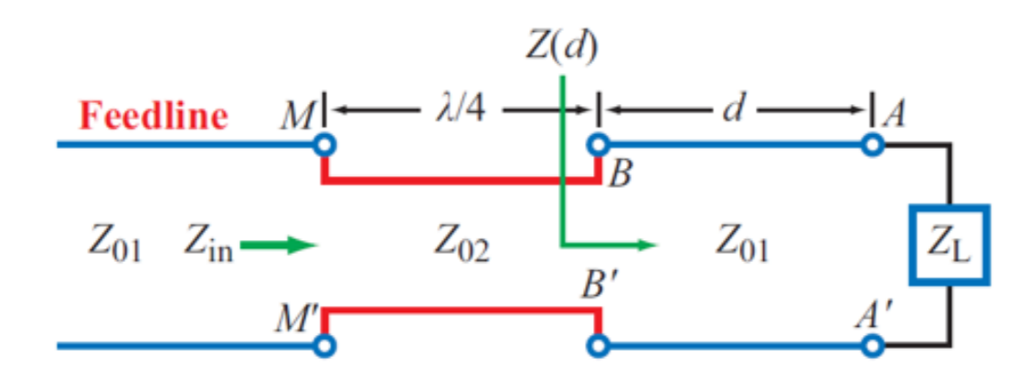

Figure : Lab 4 Matching Circuit

# Theory

Let’s start by explaining what the quarter wavelength transmission line in figure two does.

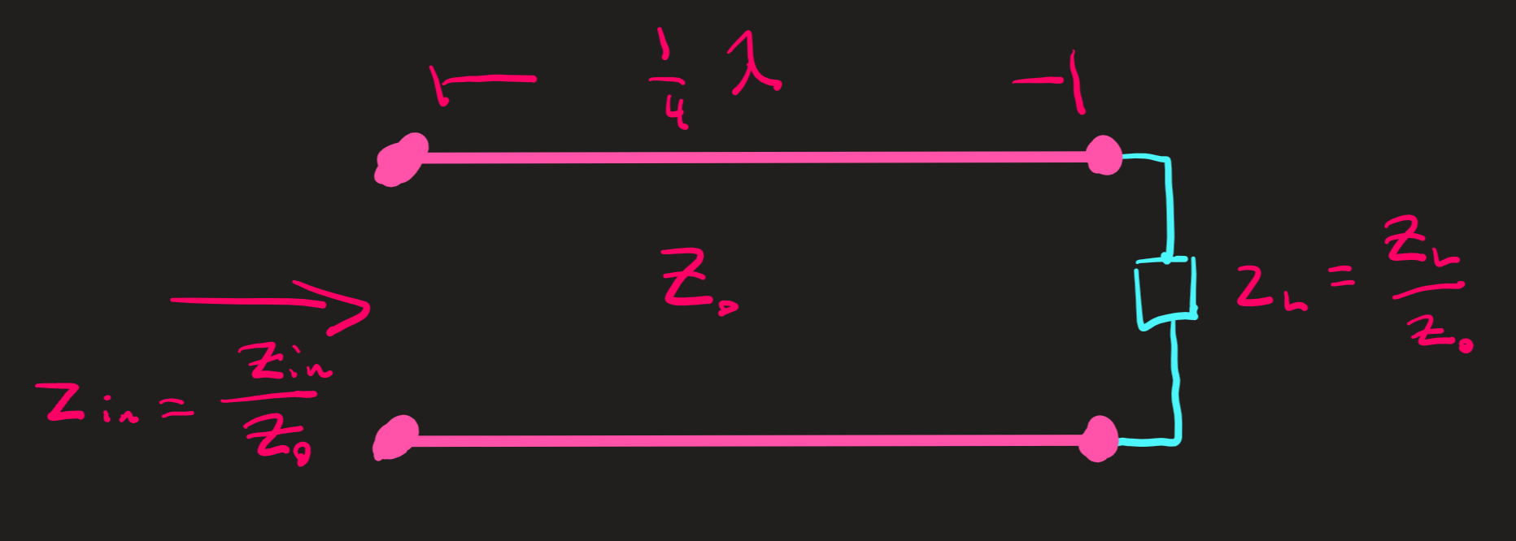

Figure : Quarter Wavelength Transmission Line

The quarter wavelength t-line imposes the following relationship

Where zL and zin are dimensionless, normalized impedances and yL is a normalized admittance. In addition to that, when working with a smith chart, the quarter wavelength t-line simply rotates the point 180° about the origin along a constant gamma circle.

The more general equation for in input impedance of a transmission line network is as follows

When the argument of the tangent is set to pi by two, the equation becomes the equation for a quarter wavelength transmission line.

The following is to be used to find the wavelength

# Results

## Smith Charts

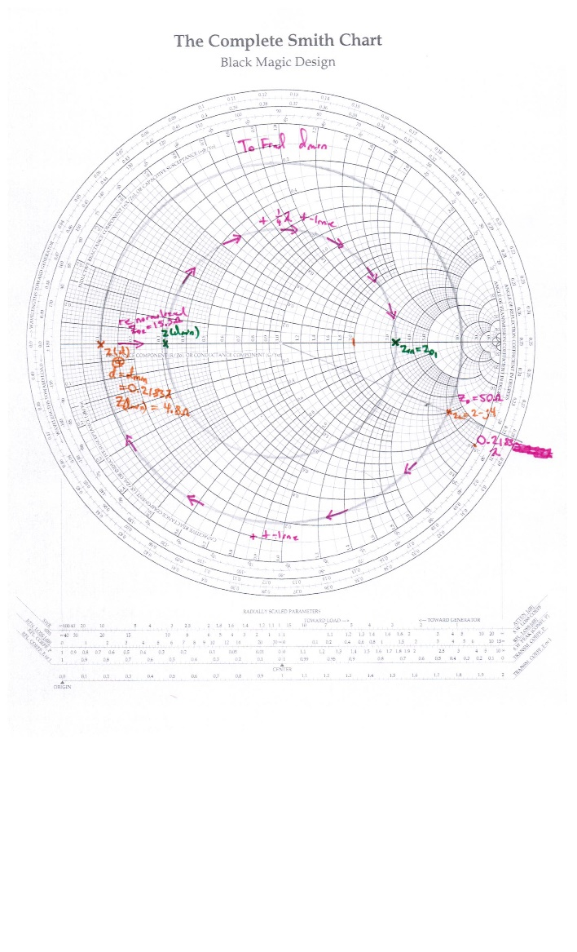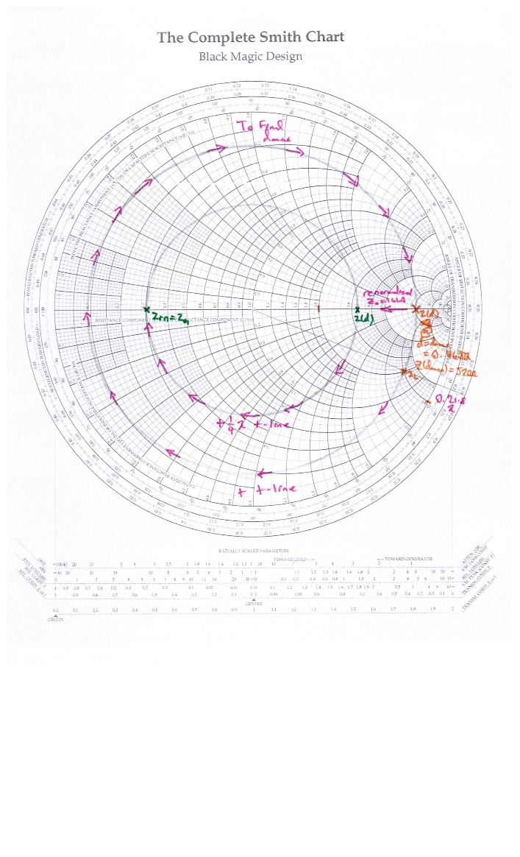

Figure : Smith Chart to find dmin Figure 4: Smith Chart to find dmax

## Simulation Results

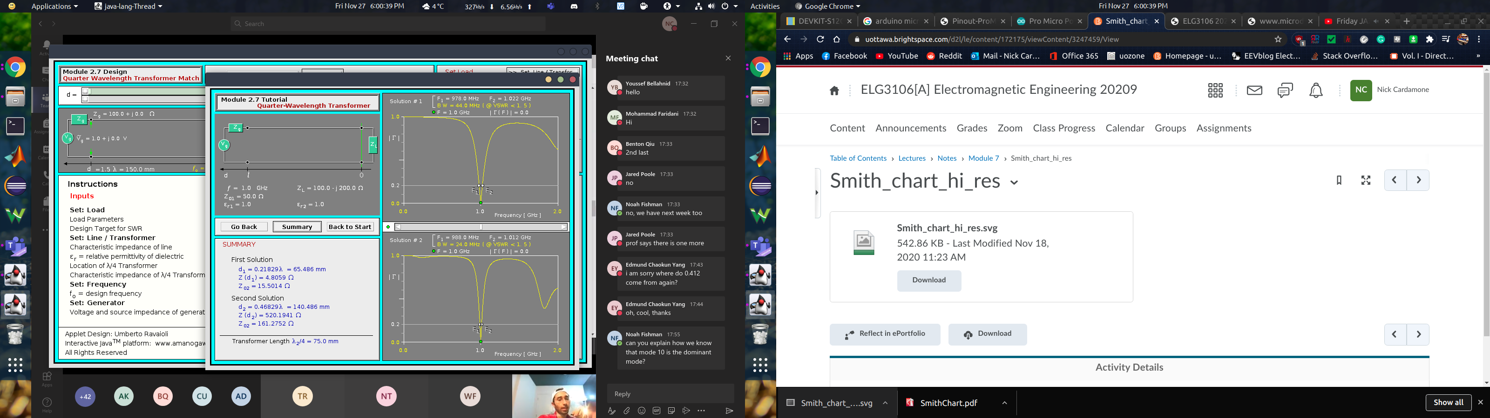

Figure : Tutorial Java App

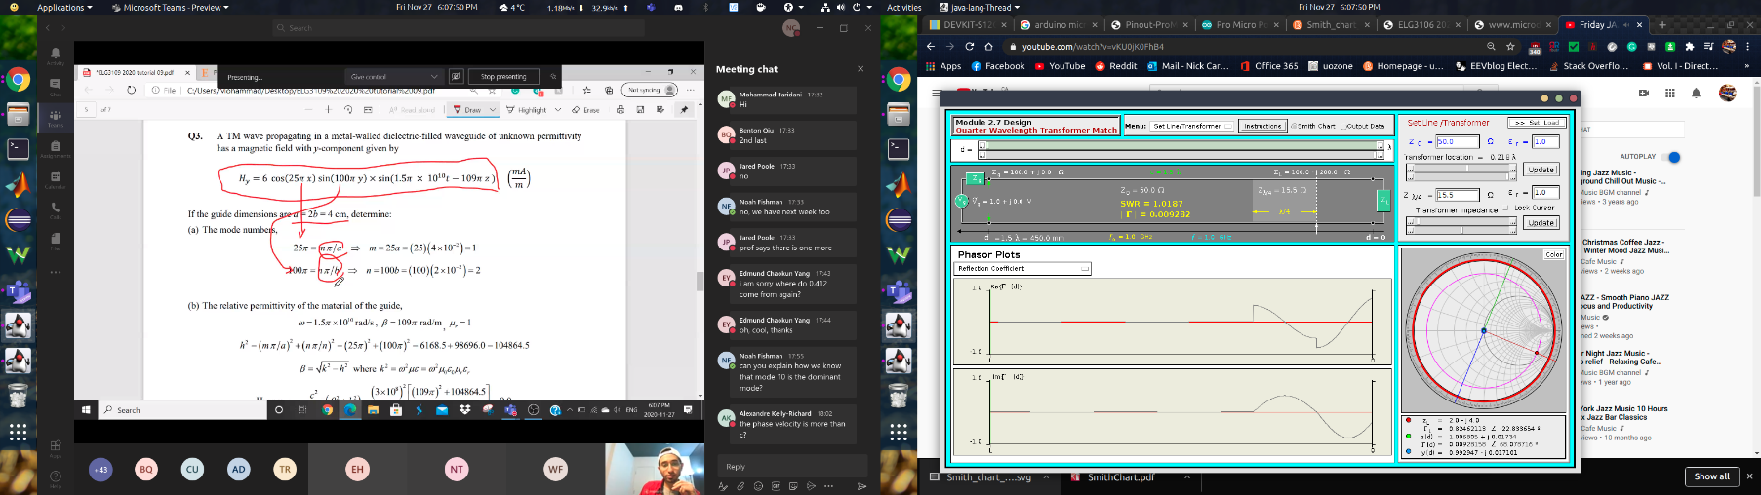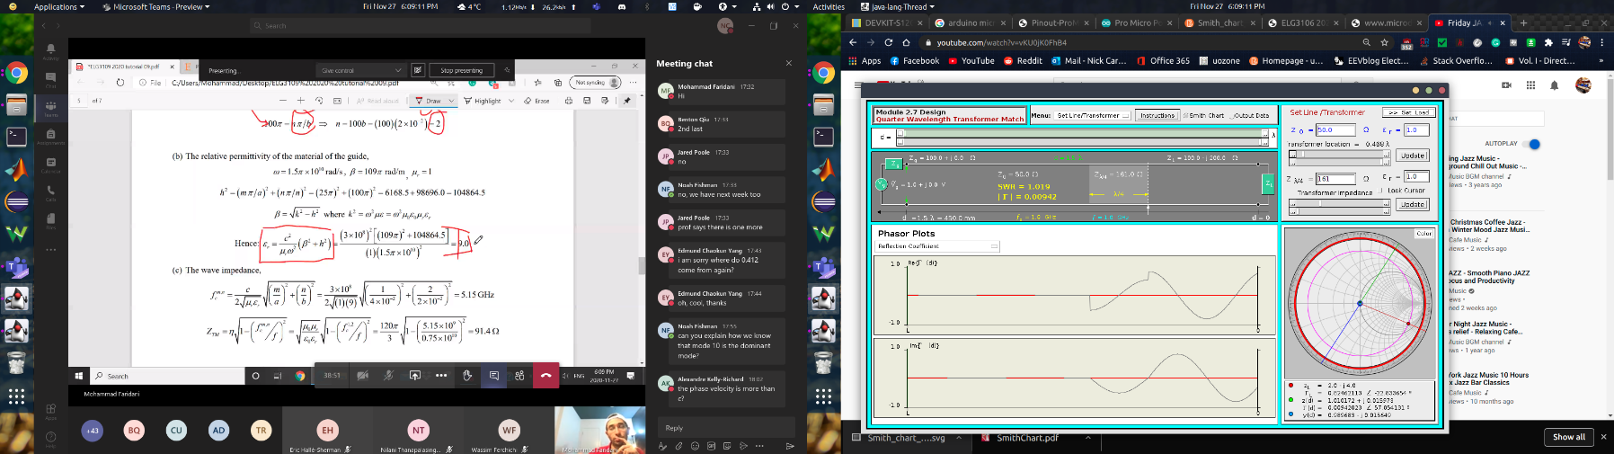

Figure : Design Java App, dmin Figure 7: Design Java App, dmax

## Numerical Results

Table : Numerical Results

|  |  |  |
| --- | --- | --- |
| Label | Value | Value |
| λ | -- | 0.3m |
| dmin | 0.218 λ | 65.5mm |
| dmax | 0.468 λ | 140mm |
| Z(dmin) | 0.1 | 4.81Ω |
| Z(dmax) | 10 | 520Ω |
| Z02 @ dmin | -- | 15.5Ω |
| Z02 @ dmax | -- | 161Ω |

# Discussion

## Design Approach

For the design of this matching network, I’ve broken the problem up into two subproblems. To explain them, it makes more sense to work backwards so that I will explain them backwards.

### Step Two

The second step to solving the problem is to find the characteristic line impedance Z02 of the quarter wavelength t-line. To start, we know that the input impedance to the matching network must be a real 50 Ω. When plotting that on the smith chart, it will be somewhere on the horizontal axis where all reactances are zero. Next, when working with quarter-wavelength t-lines, we know that the only effect they have is to rotate impedances around a constant gamma circle by 180°. Since we are asserting that Z02 is entirely real, Z(d) must also be real, and hence lye on the horizontal axis, regardless of the impedance it is normalized to. Now that we have one coordinate locked in for Z(d), we can find the other.

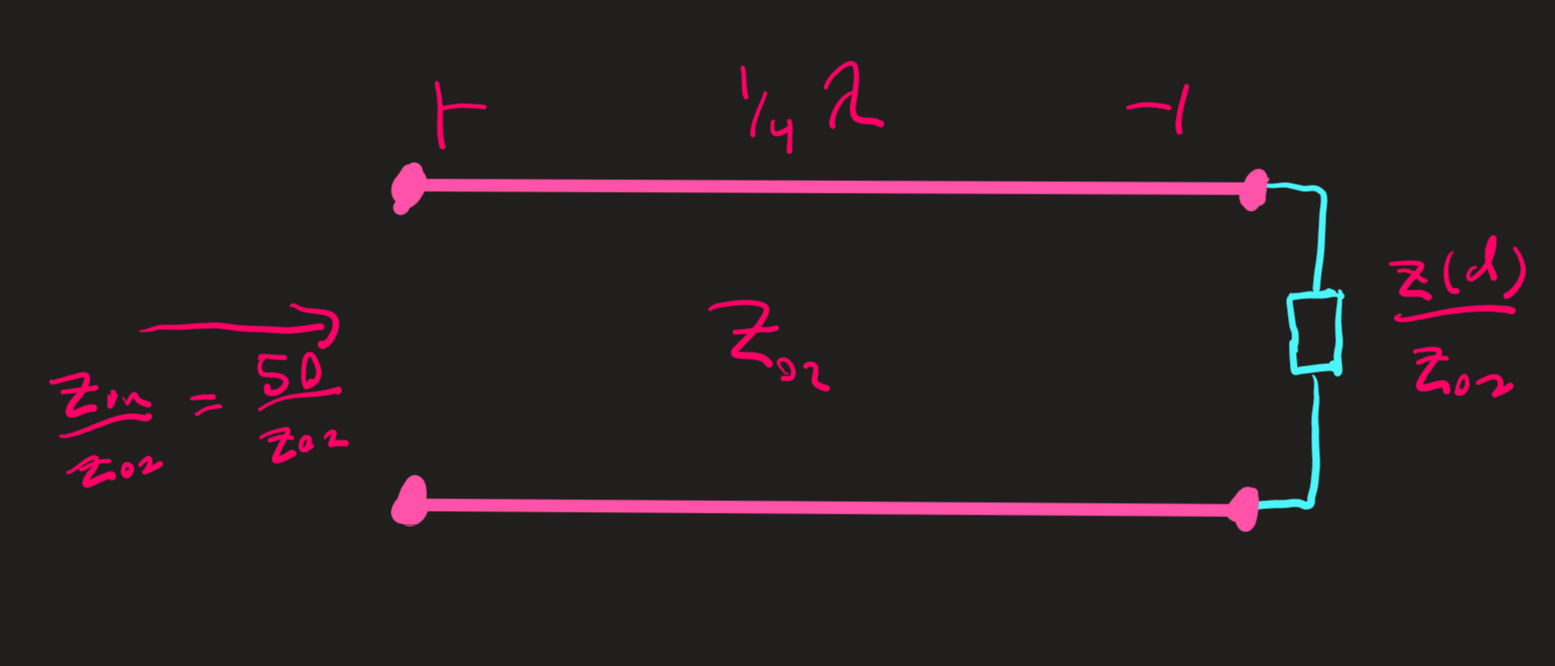

Figure : Step Two Sub Circuit

### Step One

Following from step two, we know where Z(d) should end up on the smith chart. We already know where zL is, and if we add another transmission line between the load and the quarter wavelength t-line, we can get rid of the reactive part of zL. Said another way, all that the intermediate t-line does is rotate zL along a constant gamma circle. If we choose the length of that intermediate line correctly, zL and thus Z(d) does not have any reactive component. After this is done, it would seem like there is a problem; the quarter wavelength t-line only rotates impedances by 180°. How are we supposed to change the magnitude of the impedance vector? Well, the key insight here is that the characteristic impedances here do not match. Because they are real and don’t match, this allows Z(d) to move along the horizontal axis when it is renormalized to Z02. Applying the quarter wavelength t-line equation while taking into account the different normalized impedances allows us to solve for Z02.

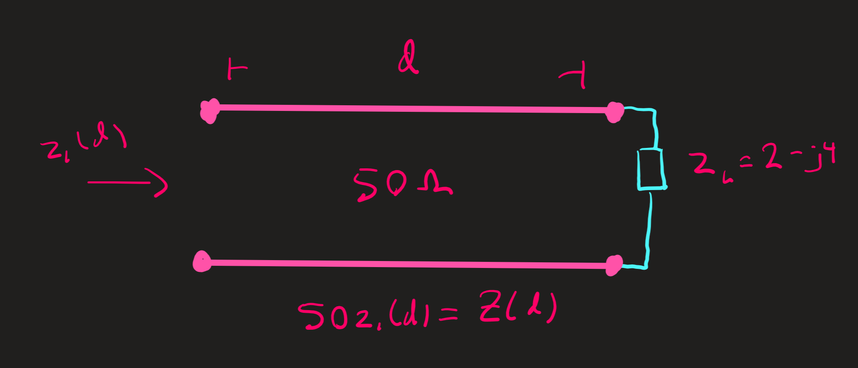

Figure : Step One Sub Circuit

### The Two Solutions

Since we are looking for when Z(d) hits the horizontal axis by rotating it on a circle, this leads to two possible distances, and thus two possible characteristic impedances, Z02. Those solutions happen to lie on opposite ends of the smith chart.

## Java App Comparison

The results between the java apps and calculations are consistent with each other. When the reflection coefficient was obtained from the java design app, it was pretty close to, but not exactly zero. That is because I rounded the value that was entered into the app.

# Conclusion

In conclusion, through the use of a smith chart and the java apps, we could determine the two separate solutions for the matching network parameters. A key take away is that the mismatch of line impedances between the quarter wavelength t-line and the others allows us to scale the magnitude of the impedance vector, while the quarter wavelength line itself shifts the angle.

Note: in the lab manual, it said to use the vector image of the smith chart. Instead, I used the regular black magic design. I did this because printing off another smith chart would not improve the quality of the lab report. Yes, the vector has a higher resolution, but the bottleneck is my printer and scanner. If I were to annotate the smith chart on my tablet in OneNote, I would not be able to draw accurate circles. Either way, there are trade-offs regardless of the smith chart being used.